Expansion of sde data center

By Rasmus Høholt Jensen – H2K|SERViCE-Provider



Indholdsfortegnelse

Pre-words: 2

IT Service management (begreber) 3

CASE hosting of fronter and filecloud: 4

Business justification: 4

Digital setup hosting of Fronter & Filecloud: 5

Physical setup for hosting fronter and filecloud: 5

Setup (loaner system): 6

ITIL 8

Mockups: 9

Incident report (Supporter side): 9

Incident report (User side): 10

Request a loaner: 10

Dashboard (Incidents) mockup: 11

Incident categories and subcategories: 11

Incident priority table: 12

# Pre-words:

During my time at LEGO, I was actually put in charge of creating a sustainable solution to our end-users, so if their PC´ needed support that couldn´t be fixed within an hour, they would get a loaner PC. In order to create such a system, I would need a certain amount of PC´s. I put a sticker with a barcode label on the back of the pc´s, so I was able to scan them (with a man in the middle script I made) directly into my SQL database, quite nice and easy. To loan a loaner PC you would need a ticket nr. from the support-ticket in service-now and fill in a form on the intranet. I would then know when and where the user would need a loaner PC and had a fine amount of time to deliver the PC to the end-user. By doing it this way, we would have data from table matching the supporting tickets from the end-users who had the needs of a loaner pc. Not to everyone´s surprise one of the KPI for the team was measured by the end-users support ratings of our service, and so the projected ended up scaling into that KPI 😊   
  
If any end-user would have a PC-breakdown and needed a loaner asap, I made sure that there always was 4-5 loaner PC´s out in the receptions around Billund. The reception got a “default” ticket-number to fil in, so the end-user didn’t had to do anything else than bring their PC to the reception.  
  
 When their own pc was back on track again, I would withdraw the loaner for their PC. This was either done by phone or email and was handled by the receptions.   
  
By doing it this way, I made sure of the end-user always had 1 PC, and that the loaner didn´t get thrown into a dark corner if they had their own pc handed out without bringing back the loaner.   
But at times, people forgot their PC home and needed a loaner for the day. These PC´s would have a lease period of 1 day only, and the other PC´s had a lease period of the service-ticket.

# IT Service management (begreber)

* ITIL
  + ITIL is a framework of best practices for delivering IT services. The ITIL approach to IT service management can help business manage risk, strengthen customer relations, establish cost-effective practices, and build a stable IT environment that allows for growth, scale and change.
* CMDB
  + A CMDB is a repository that acts as a data warehouse – storing information about your IT environment, the components that are used to deliver IT services. The data stored in a CMDB include list of assets (CI items, configuration items) and the relationships among them.
* ITSM
  + Is a mix of services for the organization. It comes in a mix of technology, processes and people that supports delivery ranging from design to continuous improvement. (Worked at LEGO we were using ServiceNow and before that another system I do not recall). This system was used by the supports, from ticket handling, replacing, etc.   
    From start – User has a problem, creates a ticket, supporter picks it up, solves the case, closing the case, and last step is to make sure the user had a good experience and got their case solved, so we sent out these “Rate us” emails when the case was closed.
* RFC
  + A formal request for a change to be implemented. An RFC includes all the information required to approve a change.
  + Understand why the change is being made, how it will be made and what it is supposed to accomplish by: Reason, Description and implementation steps.
* SLA
  + SLA, Service level Agreement is a commitment between a service provider (EG. Microsoft) and a client. Aspects of the service (Quality, availability and responsibilities are agreed between the (service)provider and the (service)user.
* /WHOAMI
  + Rasmus Høholt Jensen, Working at Hessel previously LEGO (LEGO life app iOS Side), working “behind the scene” making sure everything goes what it is suppose to go. Making sure the mechanics are getting their workcards, making sure everything goes into DocuBizz. Been working with AutoStore Servers for a while now ( KOFAX ).   
    What I would like to do… I don’t really know yet, besides I wanna be more the developer type of guy (preferable frontend), instead of the maintenance guy.

# CASE hosting of fronter and filecloud:

SDE wants to expand their datacenter. Every department must use SDE datacenter for consolidation of the infrastructure. What needs to be made:

* Hosting of fronter and filecloud within the company.
* Make use of considerations of ITIL.
* Loaner system.
  + Consisting of
    - CI
    - Lease
    - Purpose
* Interface as mockup.
  + Web / app
* UX on the user side.
* UML Diagram.

### Business justification:

We have been running head over heels with the setup we have of this day. With multiple breakdowns during the day, students not being able to neither get material on fronter nor having the chance of uploading elements bigger than 50 kb to their filecloud, it has been determined by the directional board that we need to expand our current datacenters.   
Looking at the long term run we will get.

* A long-term sustainable solution.
* Cheaper maintenance of the systems.
* Fewer breakdowns.
* More space and students being able to upload 2 GB. Files to their filecloud.
* Better workflow during the day.
* Implementations of ITIL to continuous improve on the subject.

With this, the board also wants to implement a loaner system for the students and teachers.

## 

## Digital setup hosting of Fronter & Filecloud:

The setup for hosting fronter and filecloud will be as follows:

* SQL
  + User management
    - Use of existing user DB for access to Fronter & (intra)Filecloud.
    - Setup access levels for
      * Teachers/Students
        + Access to the intranet containing (intra)filecloud and fronter.
      * Supporters
        + Access to fronter & (intra)Filecloud.
        + Extended rights as of needs for maintaining.
  + Hardware management
    - Use of existing table network/CI of switches needed for the setup
    - Use of existing table network/CI of routers needed for the setup
    - Use of existing table for physical equipment/Racks
    - Creating of new views
      * New view for fronter equipment setup.
      * New view for filecloud equipment setup
* Interface
  + Fronter
    - Intuitive.
    - User friendly
    - Teacher logon
    - Student logon
  + FileCloud
    - Can be accessed as a network drive
    - Intuitive.
    - Student logon
    - Teacher logon
* VPN
  + Access from outside the network to students & teachers for intra filecloud.
* Filecloud
  + Access possibilities:
    - Network drive through VPN
    - Through Web
    - Max 50 GB of storage for each user
* Fronter
  + Access possibilities:
    - Through Web

## Physical setup for hosting fronter and filecloud:

* Datacenter Vejle
  + 3 Rack Switches
    - Cisco catalyst 9400 24 ports switch with vlan configuration.
    - Configuration time approx. 6 hours.
  + Rack router
    - Cisco ISR 1000
    - Configuration time approx. 4 hours
  + ESXi host
    - Powerful server for hosting of local servers.
    - Configuration time approx. 2 days
  + Rack cabinet
    - Configuration time approx. 2 hours.
* Datacenter Odense
  + 3 Rack Switches
    - Cisco catalyst 9400 24 ports switch with vlan configuration.
    - Configuration time approx. 6 hours.
  + Rack router
    - Cisco ISR 1000
    - Configuration time approx. 4 hours
  + ESXi host
    - Powerful server for hosting of local servers.
    - Configuration time approx. 2 days
  + Rack cabinet
    - Configuration time approx. 2 hours.
  + Misc
    - Connecting the physical devices approx. 4 hours

# Setup (loaner system):

The setup for the loaner system will be as follow:

* SQL ( CMDB )
  + *Table for loaner CI´s*
    - *UniqueID*
    - *Brand*
    - *Model*
    - *Age*
  + *Table for users*
    - *Use of existing user DB.*
  + *View for constraint users with a loaner CI.*
    - *CI ( Loaner )*
    - *Ticket-ID*
    - *Username*
* Web form for requesting a loaner PC.
  + *Intuitive. (for eliminating human errors).*
    - *One “Request a loaner”-button.*
    - *Inputs from user:*
      * *Name*
      * *TicketID*
      * *ID*
      * *Location*
      * *Business purpose*
  + *Standard ticket ID for the receptions.*
* Receptions/IT-Support departments in various locations.
  + *Standard ticket number.*
  + *Always 4-5 PC´s in stock.*

*Keep in mind:*

ONLY PC´S OUT OF WARRANTY CAN BE USED AS A LOANER

# ITIL

For the service provided by H2K|ServiceProvider will follow the general best practice within the Information technology infrastructure library. This means for your business:

* Service Design
  + Our deal on how the service is being supplied to your company.
* Service Operation
  + When the service is operational, we will look on improvements and redo the loop continuously.
* Service transition
  + Full transparency on the implementing of your new services consisting of in-house hosting of filecloud and fronter.

ITIL is best described as a loop with service strategies followed by continual service improvement. Here is a graph describing ITIL:

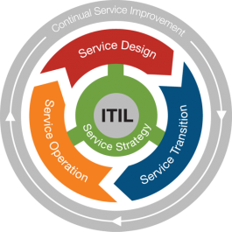

# Mockups:

## Incident report (Supporter side):

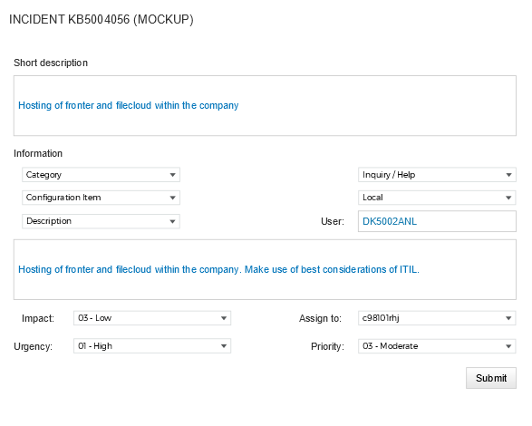

## Incident report (User side):

## Request a loaner:

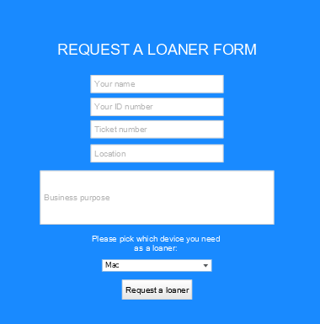

## Dashboard (Incidents) mockup:

# Incident categories and subcategories:

* **Inquiry/help**
  + *Antivirus*
  + *Email*
  + *Internal application*
* **Software**
  + *Email*
  + *Operating system*
  + *Software*
* **Hardware**
  + *CPU*
  + *Disk*
  + *Keyboard*
  + *Memory*
  + *Monitor*
  + *Mouse*
  + *Headphones*
* **Network**
  + *DHCP*
  + *DNS*
  + *IP ADDRESS*
  + *VPN*
  + *Wireless*
* **Database**
  + *SQL*

|  |  |  |  |  |
| --- | --- | --- | --- | --- |
| Priority for Impact x Urgency | | Impact | | |
| 1 - High | 2 - Medium | 3 - Low |
| Urgency | 1 - High | 1 - Critical | 2 - High | 3 - Moderate |
| 2 - Medium | 2 - High | 3 - Moderate | 4 - Low |
| 3 - Low | 3 - Moderate | 4 - Low | 5 - Planning |

## Incident priority table: